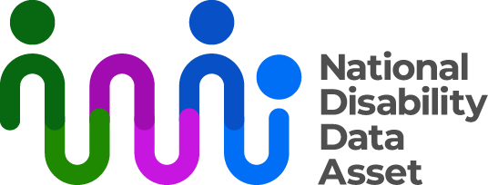

Making disability research more inclusive - plain language factsheet
The Disability-informed Ethical Oversight Panel (Panel) created a guide. This guide is about research using government data. The guide aims to help researchers do research that is more inclusive.
The guide includes three principles.
- Disability specific considerations

Researchers need to consider what language to use. Person first language is “person with disability”. Identity first language is “disabled person”. Person first language is common. Some communities may prefer identity first language.

It is important that research is neurodiversity affirming. This accepts that differences in the way people think are part of being human. Research should not describe neurodivergent people as lacking or having weaknesses.

Research should use the social and human rights models of disability. The social model says the cause of disability is the environment, not the person. The human rights model says people with disability should have equal rights.

Inclusive research should involve people with disability as partners, not just as participants. People with disability should help shape the research and decisions about topics.

Trauma-informed research
Researchers must adopt a trauma-informed approach. This means creating safety and trust. This is done by being open, transparent and collaborating with people with disability.

Intersectionality
People should not be defined by their disability. Research should consider the full experience of their identities. Researchers need to be aware of their own biases. They need to make sure research reflects different perspectives. Researchers should involve communities as co-leaders of the research.

